**Project Design Phase-II Technology Stack (Architecture & Stack)**

|  |  |
| --- | --- |
| Date | 10 November 2022 |
| Team ID | PNT2022TMID46219 |
| Project Name | Natural Disasters Intensity Analysis And Classification Using Artificial Intelligence |
| Marks | 4 marks |

Technical Architecture:

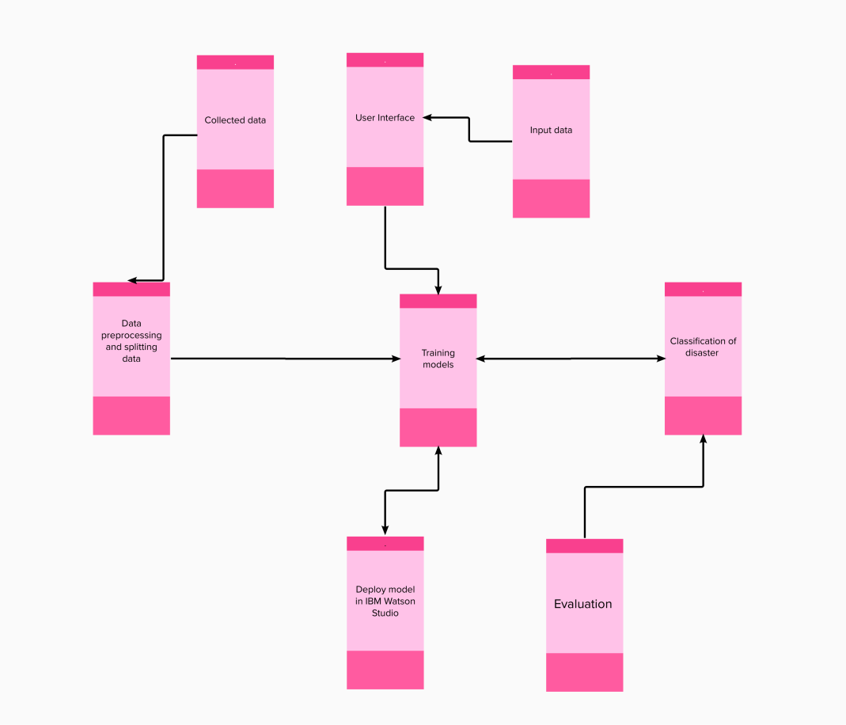

**Table-1: Components & Technologies:**

|  |  |  |  |
| --- | --- | --- | --- |
| **S. No** | **Component** | **Description** | **Technology** |
| 1. | User Interface | User interacts with application for the prediction of  Any Natural disaster which will happen in future minutes. | HTML, CSS, JavaScript, Django, Python. |
| 3. | Disaster Prediction | This function is used to predict outcomes from the new trained data to perform new tasks and solve new problems. | Decision trees, Regression, Neural networks. |
| 4. | Evaluation system | It monitors that how Algorithm performs on data as well as during training. | Chi-Square, Confusion Matrix, etc. |
| 5. | Input data | To interact with our model and give it problems to solve. Usually this takes the form of an API, a user interface, or a command-line interface. | Application programming interface, etc. |
| 6. | Data collection unit | Data is only useful if it’s accessible, so it needs to  be stored ideally in a consistent structure and conveniently in one place. | IBM Cloud, SQL Server. |

**Table-2: Application Characteristics:**

|  |  |  |  |
| --- | --- | --- | --- |
| **S. No** | **Characteristics** | **Description** | **Technology** |
| 1. | Open-Source Frameworks | An open source framework is a template for software development that is designed by a social network of software developers. These frameworks are free for public use and provide the foundation for building a software application. | Keras, Tensor flow. |
| 2. | Authentication | This keeps our models secure and makes sure only those who have permission can use them. | Encryption and Decryption (OTP). |
| 3. | Application interface | User uses mobile application and web application to interact with model | Web Development (HTML,CSS) |
| 4. | Availability (both Online and Offline work) | Its include both online and offline work. As good internet connection is need for online work to explore the software perfectly. Offline work includes the saved data to explore for later time. | Caching, backend server. |
| 5. | Regular Updates | The truly excellent software product needs a continuous process of improvements and updates. Maintain your server and make sure that your content is always up-to-date. Regularly update an app and enrich it with new features. | * Waterfall Approach * Incremental Approach * Spiral Approach |
| 6. | Personalization | Software has features like flexible fonts, backgrounds, settings, colour themes, etc. which make a software interface looks good and functional. | * CSS |